**OUTPUT:**

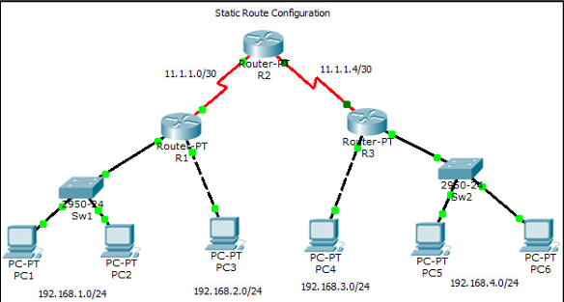

**MARK ALLOCATION:**

|  |  |  |  |
| --- | --- | --- | --- |
| Exercise Understanding | **4** |  |  |
| Execution | **4** |  |
| Documentation | **2** |  |
| Total | **10** |  |

**RESULT:**